***Web Systems & Technologies***

***ITL-226***

***Lab Journal 3***



**Student Name: Malik Huzaifa Awais Abbas**

**Enrolment No: 01-135231-046**

**Class and Section**

**Department of Computer Science**

**BAHRIA UNIVERSITY, ISLAMABAD**

**Lab # 3: HTML and HTML5**

**Objectives:**

Learn about HTML and HTML5

**Tools Used:**

Visual Studio

**Submission Date:**

**Evaluation: Signatures of Lab Engineer:**

**Create a repository on GitHub with a Relevant Lab Number and commit your solution to the repository with appropriate messages.**

**Task # 1:**

Create the following tables using HTML:

* 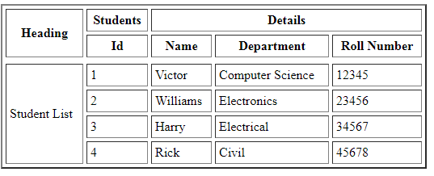
* 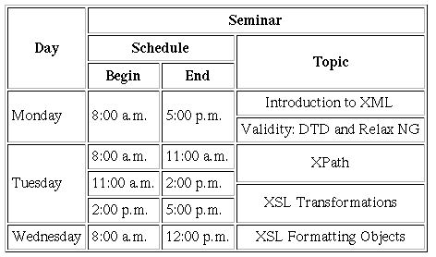

**Procedure/Program:**

<!DOCTYPE html>

<html lang="en">

<head>

    <meta charset="UTF-8">

    <meta name="viewport" content="width=, initial-scale=1.0">

    <title>Document</title>

    <link rel="stylesheet" href="./lab.css">

</head>

<body>

    <table>

        <tr>

            <th rowspan="2">Heading</th>

<th >Student</th>

<th colspan="3">Details</th>

        </tr>

        <tr>

            <th>ID</th>

            <th>Name</th>

            <th>Department</th>

            <th>Roll Number</th>

        </tr>

        <tr>

            <td rowspan="4">Student List</td>

            <td>1</td>

            <td>Victor</td>

            <td>CS</td>

            <td>1234</td>

        </tr>

        <tr>

            <td>2</td>

            <td>William</td>

            <td>Electronic</td>

            <td>2456</td>

        </tr>

        <tr>

            <td>3</td>

            <td>Harry</td>

            <td>Finance</td>

            <td>3214</td>

        </tr>

    </table>

    <table>

        <tr>

            <th rowspan="3">Day</th>

            <th colspan="3">Seminar</th>

    </tr>

    <tr>

        <th colspan="2">Schedule</th>

        <th rowspan="2">Topic</th>

    </tr>

    <tr>

        <th>Begin</th>

        <th>End</th>

    </tr>

    <tr>

        <td rowspan="2">Monday</td>

        <td rowspan="2">8.00 Am</td>

        <td rowspan="2">5.00 Am</td>

        <td>Introduction to XHtml</td>

    </tr>

    <tr>

        <td>Validity:DTD and Relax NG</td>

    </tr>

    <tr>

        <td rowspan="3">Tuesday</td>

        <td >8.00 Am</td>

        <td >11.00 Am</td>

        <td rowspan="3">XPAth <hr>Xl Transformation</td>

    </tr>

    <td >11.00 Am</td>

        <td >2.00 pm</td></tr>

    </tr>

    <tr><td >2.00 pm</td>

        <td >5.00 pm</td>

    <tr>

        <tr>

            <td >Wednesday</td>

            <td >8.00 Am</td>

            <td >12.00 pm</td>

            <td >XL Formating Object</td>

        </tr>

    </table>

</body>

</html>

**Result/Output:**

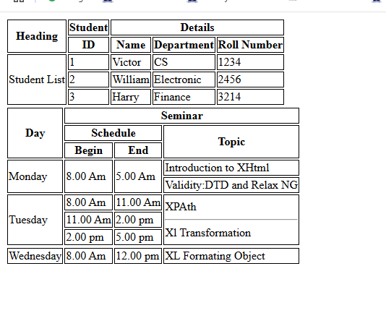

**Analysis/Conclusion:**

**Task # 2:**

Create the following web page using HTML Semantic Elements, i.e., section, aside, article, nav, header, footer, etc. Your web page must look similar to the following example.

**Code:**<!DOCTYPE html>

<html lang="en">

<head>

    <meta charset="UTF-8">

    <meta name="viewport" content="width=device-width, initial-scale=1.0">

    <link rel="stylesheet" href="./lab3.css">

    <title>Pakistan Economy</title>

</head>

<body>

    <header>

        <h1>Pakistan Economy</h1>

        <p>A look at the economic landscape of Pakistan</p>

    </header>

    <nav>

        <a href="#">Overview</a>

        <a href="#">Sectors</a>

        <a href="#">Challenges</a>

        <a href="#">Future</a>

    </nav>

    <main>

        <article>

            <section>

                <h2>Current Economic Situation</h2>

                <p>Pakistan's economy is currently facing a number of challenges, including inflation, debt, and a trade deficit. The government is taking steps to address these issues...</p>

            </section>

            <section>

                <h2>Key Economic Indicators</h2>

                <p>Here are some important economic indicators for Pakistan:</p>

                <ul>

                    <li>GDP Growth: (Insert Data)</li>

                    <li>Inflation Rate: (Insert Data)</li>

                    <li>Unemployment Rate: (Insert Data)</li>

                </ul>

            </section>

            <section>

                <h2>Major Industries</h2>

                <p>Pakistan has several important industries, including textiles, agriculture, and manufacturing...</p>

            </section>

        </article>

        <aside>

            <h2>Related Resources</h2>

            <ul>

                <li><a href="#">Ministry of Finance</a></li>

                <li><a href="#">State Bank of Pakistan</a></li>

                <li><a href="#">World Bank Data</a></li>

            </ul>

        </aside>

    </main>

    <footer>

        &copy; 2025 Pakistan Economy Updates

    </footer>

</body>

</html>

**Procedure/Program:**

**Result/Output:**

**Analysis/Conclusion:**